Appendix A
Treasury Management Activity 3rd Quarter Report 2014-15

- Background
The County Council’s treasury management activity is underpinned by CIPFA’s Code of Practice on Treasury Management (“the Code”), which requires authorities to produce annually Prudential Indicators and a Treasury Management Strategy Statement on the likely financing and investment activity. The Code also recommends that members are informed of treasury management activities at least twice a year.

This report considers treasury management activity between 1st September and 30 November 2014.

- Economic Overview
There is momentum in the UK economy, with a continued period of growth through domestically-driven activity and strong household consumption. There are signs that growth is becoming more balanced. The greater contribution from business investment should support continued, albeit slower, expansion of the UK's Gross Domestic Product (GDP). However, there are no signs of inflationary pressure and this is likely to remain the case at least for the short-term. There have been large falls in unemployment but levels of part-time working, self-employment and underemployment are significant and nominal earnings growth remains weak and below inflation.

The Monetary Policy Committee's (MPC) focus is on both the degree of spare capacity in the economy and the rate at which this will be used up, factors prompting some debate on the Committee. Despite two MPC members having voted for a 0.25% increase in rates at each of the meetings from August 2014 onwards, some Committee members have become more concerned that the economic outlook is less optimistic than at the time of the August Inflation Report.

The transposition of two European Union directives into UK legislation in the coming months will place the burden of rescuing failing EU banks disproportionately onto unsecured local authority investors. The Bank Recovery and Resolution Directive promotes the interests of individual and small businesses covered by the Financial Services Compensation Scheme and similar European schemes, while the recast Deposit Guarantee Schemes Directive includes large companies into these schemes. The combined effect of these two changes is to leave public authorities and financial organisations (including pension funds) as the only senior creditors likely to incur losses in a failing bank after July 2015.

2.1 Interest Rate Environment

Short term interest rates continue at the very low levels since the Bank of England reduced the base rate to 0.5% in March 2009. The chart below shows that there has been no movement in short term interest rates over the first three quarters of the calendar year.

Current longer term PWLB rates are shown below.

These rates are published twice a day by the UK Treasury debt management office and are calculated by adding a spread of 100 basis points to gilt yields. They are therefore a good indication of how much it would cost the County Council to finance capital expenditure through the PWLB but also of the direction of long term interest rates in general.

Following a period where central bank liquidity injections, the abatement of the euro crisis and the economic recovery had seen a reduction in demand for safe haven assets including UK Government gilts, the picture reversed during the summer of 2014 as economic indicators began to show a less rosy picture.

The autumn recorded continuing poor financial news from Europe and China, and this combined with significantly heightened geo-political risk has seen bond markets push on to even higher levels with the UK in particular continuing to set new historic lows in long term rates.

2.2 Outlook for Interest Rates

Treasury Consultants Arlingclose Ltd forecast the first rise for official interest rates to be in September 2015 with a gradual pace of increases thereafter and the average bank rate for 2015/16 being around 0.75%. Arlingclose are also forecasting that when the economy reaches the point that it can be considered to have recovered from the financial crisis, and rates rise to 'normal' levels, bank rate will range between 2.5% and 3.5%, considerably lower than pre-crisis levels.

Arlingclose consider that the risk interest rates will be higher than this forecast increases as the forecast looks further into the future beyond 2016. On the downside, the chance that interest rates will be lower than the forecast, Eurozone weakness and the threat of deflation have increased the risks to the durability of UK growth. If the negative indicators from the Eurozone become more entrenched, the Bank of England will likely defer rate rises to later in the year and so this risk is higher at the near end of the forecast.

Arlingclose expect the deteriorating Eurozone situation will result in gilt yields will remain low in the short term but still on an upward path through the medium term.

Period | Bank Rate | 3 month LIBID | 12 month LIBID | 20-year Gilt Rate
Q1 2015 | 0.50 | 0.60 | 1.00 | 2.55
Q2 2015 | 0.50 | 0.75 | 1.05 | 2.65
Q3 2015 | 0.75 | 0.90 | 1.20 | 2.75
Q4 2015 | 0.75 | 1.05 | 1.35 | 2.85
Q1 2016 | 1.00 | 1.20 | 1.50 | 2.95
Q2 2016 | 1.00 | 1.35 | 1.65 | 3.00
Q3 2016 | 1.25 | 1.50 | 1.80 | 3.05
Q4 2016 | 1.25 | 1.60 | 1.95 | 3.10
Q1 2017 | 1.50 | 1.70 | 2.10 | 3.15
Q2 2017 | 1.50 | 1.80 | 2.20 | 3.20
Q3 2017 | 1.75 | 1.90 | 2.30 | 3.25
Q4 2017 | 1.75 | 2.00 | 2.40 | 3.30
Q1 2018 | 1.75 | 2.10 | 2.50 | 3.30

  - Implications for Lancashire County Council Treasury Strategy

Since 2010 the County Council have used short term market borrowing to fund past and present capital expenditure so taking advantage of historically low interest rates. This policy has proved to be very effective in an environment where rates have stayed low for much longer than expected and continues to do so. Prospects for interest rate increases are continuously monitored and flexible arrangements are maintained to enable the Council to react in good time should the path of interest rate forecasts change.

- Current Issues
3.1 Bank 'bail-in' legislation

The European Bank Recovery and Resolution Directive which becomes UK law in July 2015 is an important consideration for the County Council's current and future investment policy. This legislation brings into law 'bail-in' arrangements whereby the first port of call to fund a failing bank will be investors rather than the taxpayer.

Although the legislation does not, in itself, increase the risk of a bank default, it does increase the County Council's credit risk, because the effect of the legislation is to place the burden of rescuing failing EU banks disproportionately onto unsecured local authority investors. Whereas individuals and companies (small and large) have some protection through compensation and deposit guarantee schemes, there are no such protections for public authorities.

In effect this increases the risks associated with fixed unsecured deposits beyond the point where they are a suitable investment vehicle for the County Council's reserves and balances. The current treasury management investment policy and active treasury management strategy already provides for the replacement of fixed deposit investments with other lower risk investment options, primarily through exposure to UK Government credit, through Gilt markets and through covered bonds which are specifically exempt from the bail-in legislation.

3.2 Liquidity Management Trades (Sell/Buy Back and Buy/Sell Back Transactions.)

After security, liquidity is the most important objective of the County Council's treasury management strategy. Liquidity is essentially the Council's access to cash.

In the past daily liquidity has been achieved through the use of bank call accounts, primarily the Special Interest Bearing account provided by the County Council's bankers Nat West (part of the Royal Bank of Scotland). However the bank bail-in legislation means that holding large amounts of cash with RBS exposes the County Council to an increased level of credit risk. If RBS was to default with the Council's funds within the call account, the Council's funds would be at risk as set out above in section 3.1.

The current treasury management policy allows for the use of the County Council's high quality securities to be used in sell/buy back transactions, whereby securities are sold to a bank counterparty and simultaneously an additional trade is agreed to buy the securities back at an agreed price on a future date. This effect of this trade is to borrow short term cash for liquidity purposes at a rate of interest implied by the difference between the selling and buying price of the securities.

A reverse of this trade can also be used to invest cash overnight or over a weekend, again using UK Government securities. These transactions have been successfully used during the year to invest cash so maintaining liquidity and reducing bank credit risk exposure. The current interest rate for these transactions is currently around 0.47% which is competitive with call account and money market fund rates therefore not exposing the Council to further costs.

- Current Treasury Management Policy

Full Council approved the 2014/15 treasury management strategy at its meeting on 27th February 2014. The Council’s stated investment priorities are:

(a) Security of capital and
(b) Liquidity of its investments.

The Council also aims to achieve the optimum return on its investments commensurate with proper levels of security and liquidity. The risk appetite of the Council is low in order to give priority to security of its investments.

The Council’s stated borrowing strategy is to take advantage of historically low short term interest rates by borrowing short term in the money markets rather than financing capital expenditure through long term Public Works Loan Board (PWLB) loans.

The County Treasurer can report that all treasury management activity undertaken during the financial year to date complied with the CIPFA Code of Practice and the relevant legislative provisions.

The current borrowing policy of keeping a higher proportion of borrowing at variable rates or short dated maturities is enabling the County Council to take advantage of the very low rates available on short term borrowing. Rates will be carefully monitored and the proportion of borrowing held on longer term fixed rates will be increased as rates are expected to rise.

The current investment policy of accessing high credit quality institutions through bond investments as opposed to placing fixed term deposits directly with banks continues to be appropriate given the continued difficult credit environment and forthcoming banking 'bail-in' legislation.

4.1 Investment Activity

The table below shows investment activity between 31 August 2014 and 30 November 2014.

 |  | Bank and Local Authority Deposits
 | Call | Fixed | Structured | Total
 | £m | £m | £m | £m
Balance 31 August 2014 | 89.28 | 56.50 | 73.81 | 219.58
Maturities | -83.30 | 0.00 | 0.19 | -83.11
New Investments | 86.47 | 0.00 | 0.00 | 86.47
Balance 30 November 2014 | 92.46 | 56.50 | 74.00 | 222.95

 |  | Bonds
 | LA Bonds | Gilts | Others | Total
 | £m | £m | £m | £m
Balance 31 August 2014 | 20.09 | 43.66 | 190.15 | 253.90
Maturities | 16.61 | -4,316.48 | -233.91 | -4,533.77
New Investments | 0.00 | 4,361.27 | 255.11 | 4,616.38
Balance 30 November 2014 | 36.70 | 88.45 | 211.35 | 336.50

Overall the level of investments have increased in the period by £85.97m. This increase is in line with cash flow movements and requirements. Bond investments now make up 60.15% of the portfolio following the active management of investment portfolios through this period of increasing geopolitical risk and deteriorating economic indicators and the Scottish referendum represented by the unusually high turnover of the gilts and other bond portfolios.

In addition liquidity management trades (described in section 3 above) increase the activity in UK Government Gilts.

The current rate of return on the investment portfolio measured by Arlingclose Ltd treasury consultants is 2.063% which compares favourably with the benchmark 7 day LIBID which averages 0.35% over the same period.

4.2 Borrowing Activity

Current market conditions continue to enable the County Council to take advantage of short term market borrowing. The table below shows the borrowing activity which has taken place between 31 August 2014 and 30 November 2014.

 | PWLB Fixed | PWLB Var | Long Term Market Loan | Other Locals | Police, Fire & Lancashire District Councils | Total
 | £m | £m | £m | £m | £m | £m
Balance 31 August 2014 | 213.10 | 125.75 | 52.27 | 507.27 | 104.66 | 1,003.05
Maturities | 0.00 | 0.00 | 0.00 | 286.00 | 139.55 | 425.55
New Borrowing | 0.00 | 0.00 | -0.38 | -157.25 | -153.85 | -311.48
Balance 30 November 2014 | 213.10 | 125.75 | 51.89 | 636.02 | 90.36 | 1,117.12

Treasury borrowing has increased over the period, for cash flow and portfolio management purposes. Total borrowing now stands at £1.236bn including the financing of £119m of assets through Private Finance Initiative schemes.

The graph below shows the level of debt for each day of the current financial year compared with the prudential indicator operational and authorised boundaries. In June the boundaries were temporarily increased to provide room for a possible bond issuance to replace the current method of short term market borrowing.

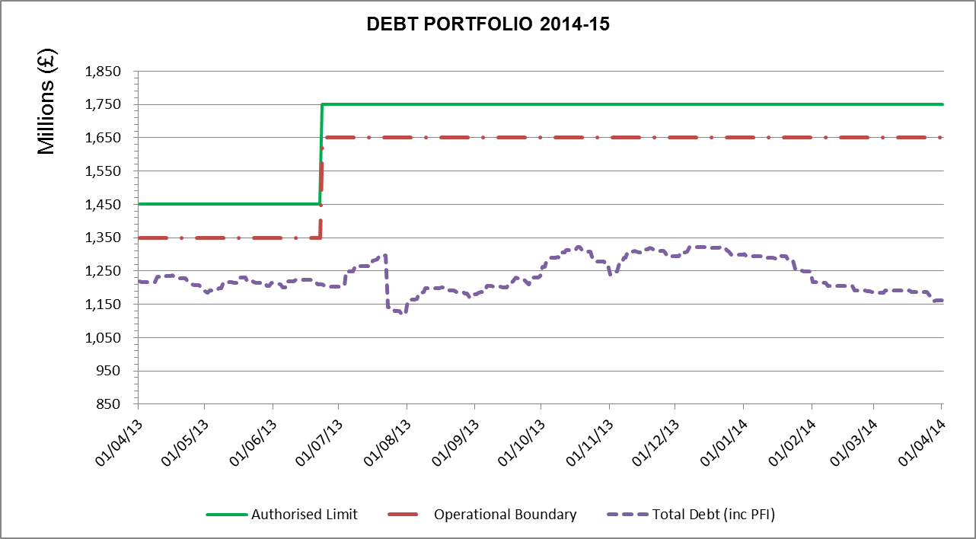

Total debt during the year has remained below the original operating boundary.

The current interest rate payable on debt measured by Arlingclose Ltd treasury consultants is 1.59%. The most recent benchmarking figure available is the average rate for all Arlingclose clients measured on 31 March 2014 of 4.14%.

- Investment in Landsbanki Is.
Under the previous Treasury Management Strategy, Lancashire County Council made a £6.4m deposit with the Icelandic Bank Landsbanki Is which was still on deposit when the bank collapsed in October 2008. During the administration process 52% of the claim was repaid through distributions by the bank winding up board and the remainder of the claim was sold at the end of November. After taking into account the principal and interest distributions and sale proceeds, Icelandic Krona exchange rate and legal costs there is a loss of £476k of the original £10m principal invested. This will not cause an overspend against the budget as it can be met from other investment income within the Council's financing charges budget which is set out below.

- Budget Monitoring Position
The financing charges budget is forecasted to be £7m underspent compared with budget at the end of the financial year. The latest underspend position will be reported to Cabinet at its meeting on 5 February.

The majority of the underspend is due to the outperformance of the County Council's bond portfolios during the last six months. Portfolio risk management in recent volatile markets has forced the turnover of the portfolios on a frequent basis and this crystallises the increase in the market value of these 'quality' assets.

In addition there is a reduction of interest payments following the refinancing of the Waste PFI project.

This position is kept under regular review taking account both of ongoing performance and also market movements and the forecast is provided to the County Treasurer on a monthly basis.

- Prudential Indicators 2013/14
The Local Government Act 2003 and supporting regulations require the County Council to have regard to the prudential code and to set prudential indicators to ensure the County Council's capital investment plans are affordable, prudent and sustainable.

A comparison of the actual position at 30 November 2014 compared to the indicators set in the treasury management strategy for 2014/15 is set out below.

 | Treasury Management Prudential Indicators |  | 2014/15 |  | 30th Nov  Actual
 |  |  | £m |  | £m
 | - Adoption of CIPFA TM Code of Practice  - Authorised limit for external debt - A prudent estimate of debt, which reflects the Authority’s capital expenditure plans and allows sufficient headroom for unusual cash movements. |  | aDoPtEd
 | Borrowing |  | 1,544 |  | 1,117
 | Other long-term liabilities(PFI schemes) |  | 206 |  | 119
 | TOTAL |  | 1,750 |  | 1,236
 | - Operational boundary for external debt - A prudent estimate of debt, but no provision for unusual cash movements. It represents the estimated maximum external debt arising as a consequence of the County Council's current plans.
 | Borrowing |  | 1,494 |  | 1,117
 | Other long-term liabilities |  | 156 |  | 119
 | TOTAL |  | 1,650 |  | 1,236
- Capital financing requirement to gross debt  Capital financing requirement (excl PFI)  Estimated gross debt  Debt to CFR |  | Estimate  645  815  126% |  | Actual  871  1,117  128%
The actual capital financing and gross debt figures are higher than the estimate as a result of refinancing the waste PFI. The estimated gross debt figure will be revised in the 2015/16 Strategy to take into account this refinancing. Gross borrowing is higher than the capital financing requirement because the shared investment scheme is accounted for as borrowing, but it does not form part of the capital financing requirement calculation.

- Treasury Management Indicators
The following indicators are set as part of adopting the treasury management code. The code states that local authorities should have regard to the following treasury indicators.
A comparison of the agreed indicators and the actual position at 30 November 2014 is set out below.

- Interest rate exposure
 | Upper limit | Actual
 | £m | £m
Net Interest Payable Fixed rate | 37.6 | 6.1
Net Interest Payable Variable rate | 5.0 | 0.5
1yr impact of 1% rise | 25.0 | 1.8

- Maturity structure of debt
 | Lower Limit % | Upper Limit % | Actual %
Under 12 months |  | 75 | 21
12 months and within 2 years |  | 75 | 46
2 years and within 5 years |  | 75 | 7
5 years and within 10 years |  | 75 | 5
10 years and above | 25 | 100 | 21

- Investments over 365 days
 | Upper limit | Actual
 | £m | £m
Total invested over 364 days | 900 | 450

- Minimum Average Credit Rating
 | Benchmark | Actual
Average counterparty credit rating | A+ | AA

- Daily Liquidity
Minimum
 | Requirement | Actual
 | £m | £m
Cash maintained on call | 20 | 92

This report on the latest Treasury management activity shows that the Treasury Management Strategy set in February is still appropriate for the current market conditions and that the level of borrowing and investments are in line with this strategy and within the indicator limits

The Council confirms that it has complied with its Prudential Indicators for 2014/15, which were approved on 20th February 2014 as part of the Council’s Treasury Management Strategy Statement.

